**МИНИСТЕРСТВО ОБРАЗОВАНИЯ И НАУКИ РОССИЙСКОЙ ФЕДЕРАЦИИ**

###### ФЕДЕРАЛЬНОЕ ГОСУДАРСТВЕННОЕ БЮДЖЕТНОЕ ОБРАЗОВАТЕЛЬНОЕ УЧРЕЖДЕНИЕ ВЫСШЕГО ОБРАЗОВАНИЯ

###### КЕМЕРОВСКИЙ ГОСУДАРСТВЕННЫЙ УНИВЕРСИТЕТ

**ИНСТИТУТ ЦИФРЫ**

**ОТЧЁТ**

**О ВЫПОЛНЕНИИ ЛАБОРАТОРНОЙ РАБОТЫ**

«Сбор данных в интернете»

Студентки 2 курса, ФИТ-211 группы

**Колесник Полины Олеговны**

Направление 02.03.02 – «Фундаментальная информатика и информационные технологии»

Руководитель:

Доцент Зимин А. И.

Работа защищена

« »

“ ” 2023 г.

Кемерово 2023 г.

**ОТЧЁТ О ПРОДЕЛАННОЙ РАБОТЕ**

**1 задание**

<http://static-maps.yandex.ru/1.x/?ll=86.091366,55.351912&spn=0.0012,0.0012&l=map>

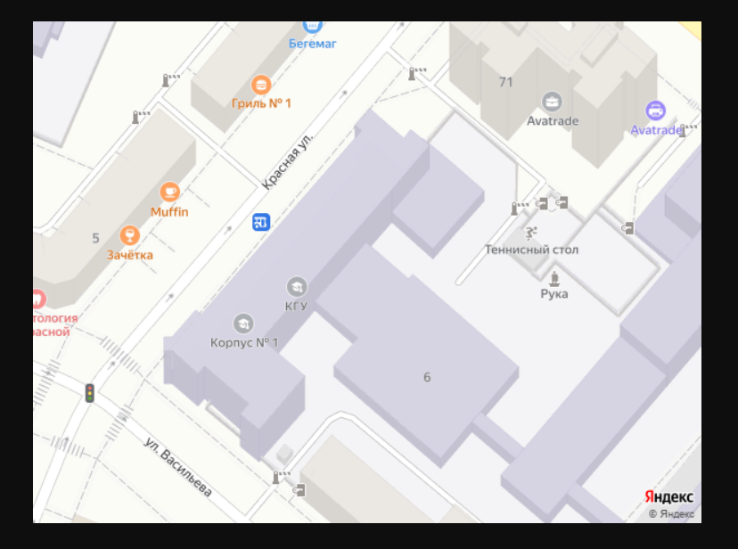

<http://static-maps.yandex.ru/1.x/?ll=86.004425,55.389714&spn=0.003,0.003&l=map>

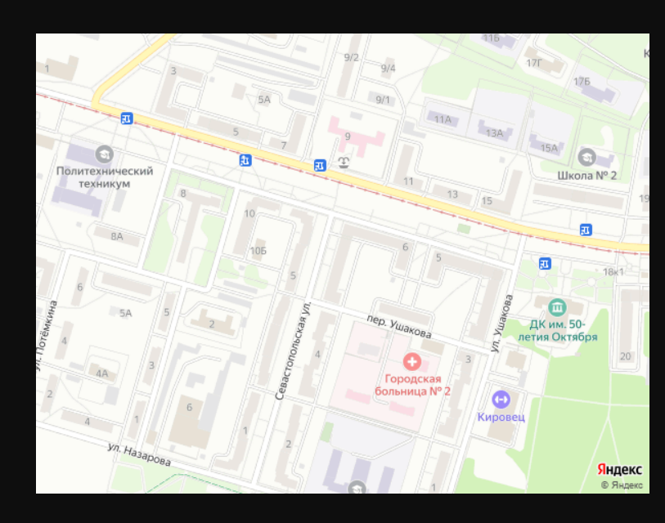

<https://static-maps.yandex.ru/1.x/?ll=86.0868478%2c55.355198&spn=0.002,0.002&l=map>

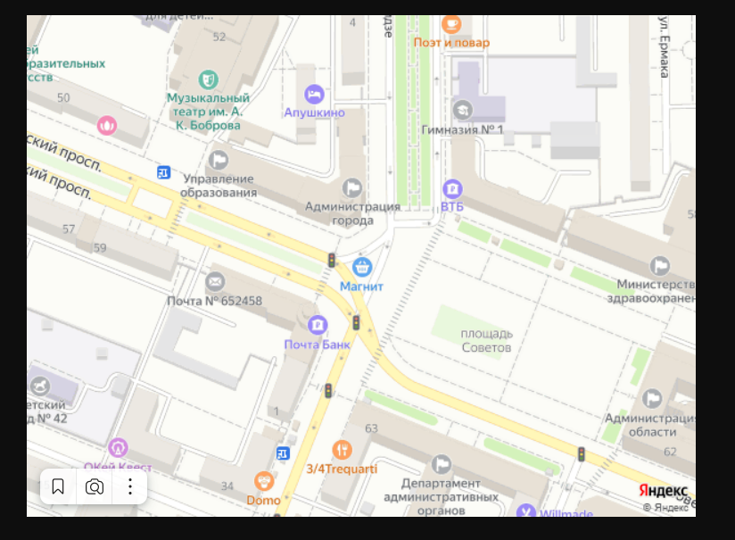

<http://static-maps.yandex.ru/1.x/?ll=2.294509,48.858319&spn=0.0012,0.0012&l=sat>

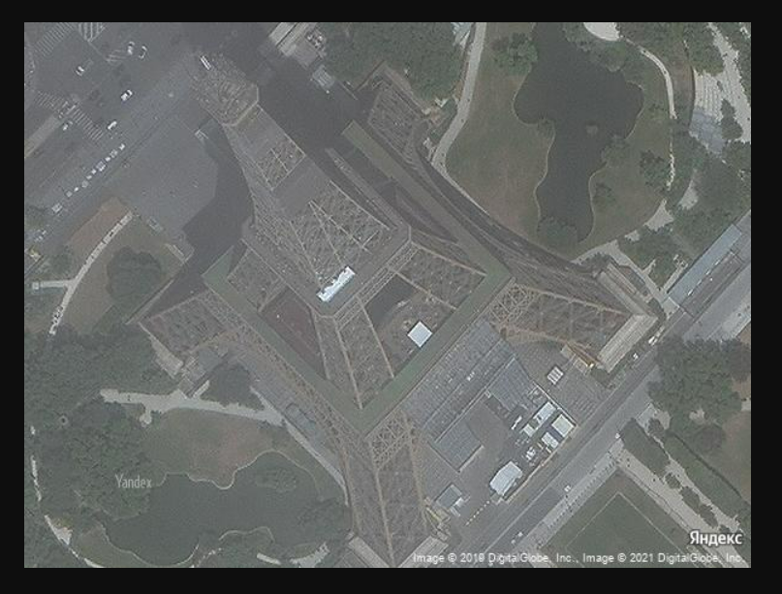

<http://static-maps.yandex.ru/1.x/?ll=158.825355,53.283671&spn=0.1,0.1&l=sat>

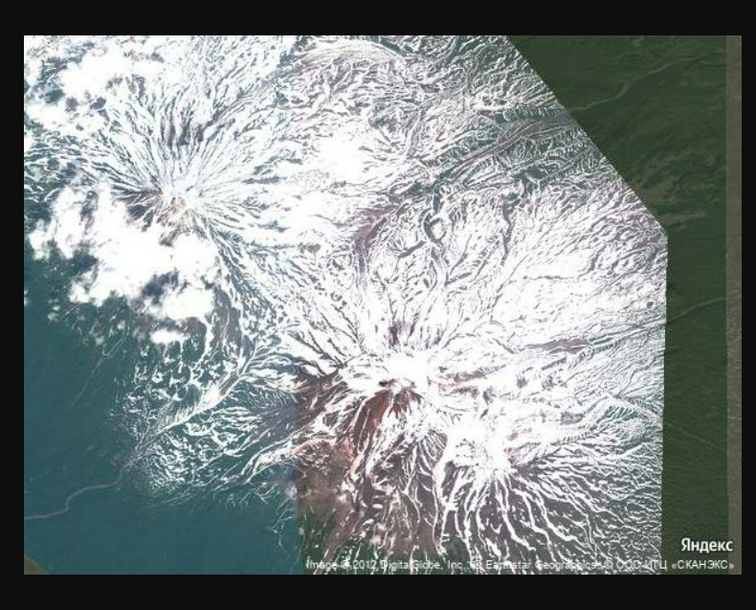

<https://static-maps.yandex.ru/1.x/?ll=108.655058%2C53.586278&spn=2.5,3.1&l=sat>

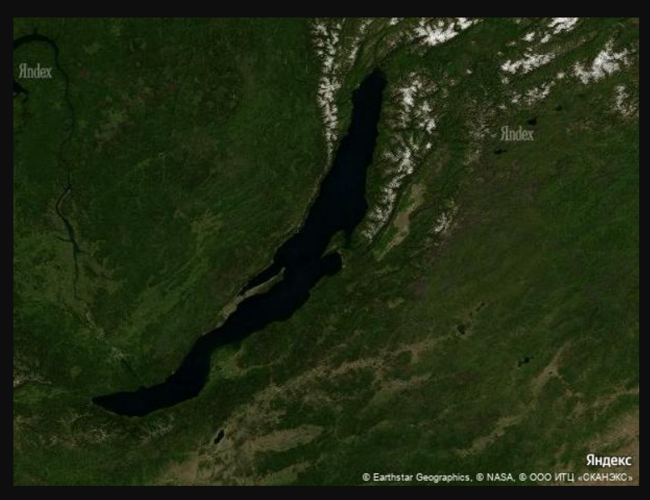

<http://static-maps.yandex.ru/1.x/?ll=63.285429,45.926979&spn=0.001,0.001&l=sat>

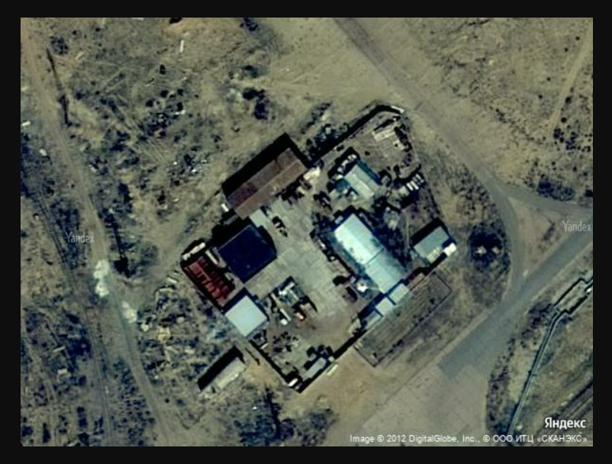

**2 задание**

*# A*

<http://geocode-maps.yandex.ru/1.x/?apikey=7a0332fa-0401-4a46-ac3c-da05786df316&geocode=Якутск&format=json>



<http://geocode-maps.yandex.ru/1.x/?apikey=7a0332fa-0401-4a46-ac3c-da05786df316&geocode=Магадан&format=json>



Якутск севернее

*# B*

<http://geocode-maps.yandex.ru/1.x/?apikey=7a0332fa-0401-4a46-ac3c-da05786df316&geocode=Кемерово&format=json>



<http://geocode-maps.yandex.ru/1.x/?apikey=7a0332fa-0401-4a46-ac3c-da05786df316&geocode=Торонто&format=json>



Торонто южнее

*# C*

<http://geocode-maps.yandex.ru/1.x/?apikey=7a0332fa-0401-4a46-ac3c-da05786df316&geocode=Хабаровск&format=json>



<http://geocode-maps.yandex.ru/1.x/?apikey=7a0332fa-0401-4a46-ac3c-da05786df316&geocode=Уфа&format=json>



<http://geocode-maps.yandex.ru/1.x/?apikey=7a0332fa-0401-4a46-ac3c-da05786df316&geocode=Нижний+Новгород&format=json>



<http://geocode-maps.yandex.ru/1.x/?apikey=7a0332fa-0401-4a46-ac3c-da05786df316&geocode=Калининград&format=json>



<http://geocode-maps.yandex.ru/1.x/?apikey=7a0332fa-0401-4a46-ac3c-da05786df316&geocode=Кемерово&format=json>



*# D*

<http://geocode-maps.yandex.ru/1.x/?apikey=7a0332fa-0401-4a46-ac3c-da05786df316&geocode=Кемерово,+ул.+Красная+6&format=json>



**3 задание**

import requests  
  
response = requests.get(  
 "http://geocode-maps.yandex.ru/1.x/?apikey=7a0332fa-0401-4a46-ac3c-da05786df316&geocode=Москва,+Красная+площадь,+1&format=json")  
json_response = response.json()  
toponym = json_response["response"]["GeoObjectCollection"]["featureMember"][0]["GeoObject"]  
toponym_address = toponym["metaDataProperty"]["GeocoderMetaData"]["text"]  
toponym_coodrinates = toponym["Point"]["pos"]  
print(toponym_address, "имеет координаты:", toponym_coodrinates)



**4 задание**

import requests  
  
response = requests.get(  
 "http://geocode-maps.yandex.ru/1.x/?apikey=7a0332fa-0401-4a46-ac3c-da05786df316&geocode=Барнаул&format=json")  
json_response = response.json()  
toponym = json_response["response"]["GeoObjectCollection"]["featureMember"][0]["GeoObject"]  
toponym_region = toponym["metaDataProperty"]["GeocoderMetaData"]["Address"]["Components"][2]["name"]  
print("Барнаул: " + toponym_region)  
  
response = requests.get(  
 "http://geocode-maps.yandex.ru/1.x/?apikey=7a0332fa-0401-4a46-ac3c-da05786df316&geocode=Мелеуз&format=json")  
json_response = response.json()  
toponym = json_response["response"]["GeoObjectCollection"]["featureMember"][0]["GeoObject"]  
toponym_region = toponym["metaDataProperty"]["GeocoderMetaData"]["Address"]["Components"][2]["name"]  
print("Мелеуз: " + toponym_region)  
  
response = requests.get(  
 "http://geocode-maps.yandex.ru/1.x/?apikey=7a0332fa-0401-4a46-ac3c-da05786df316&geocode=Йошкар-Ола&format=json")  
json_response = response.json()  
toponym = json_response["response"]["GeoObjectCollection"]["featureMember"][0]["GeoObject"]  
toponym_region = toponym["metaDataProperty"]["GeocoderMetaData"]["Address"]["Components"][2]["name"]  
print("Йошкар-Ола: " + toponym_region)

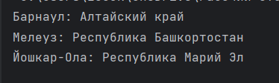

**5 задание**

import requests  
  
response = requests.get(  
 "http://geocode-maps.yandex.ru/1.x/?apikey=7a0332fa-0401-4a46-ac3c-da05786df316&geocode=Москва,+Петровка,+38&format=json")  
json_response = response.json()  
toponym = json_response["response"]["GeoObjectCollection"]["featureMember"][0]["GeoObject"]  
toponym_address = toponym["metaDataProperty"]["GeocoderMetaData"]["text"]  
toponym_postal_code = toponym["metaDataProperty"]["GeocoderMetaData"]["Address"]["postal_code"]  
print(toponym_address + " имеет почтовый индекс " + toponym_postal_code)



**6 задание**

import requests  
  
response = requests.get(  
 "https://static-maps.yandex.ru/1.x/?ll=136.737180%2C-26.661921&spn=18.0,18.0&l=sat")  
map_file = "sat_australia.png"  
with open(map_file, "wb") as file:  
 file.write(response.content)

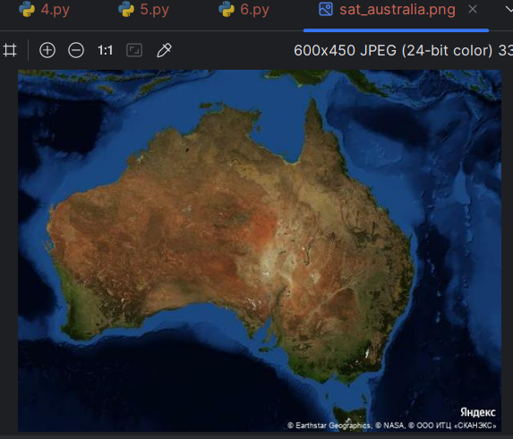

**7 задание**

import requests  
  
response = requests.get("https://static-maps.yandex.ru/1.x/?ll=86.098886%2C55.355069&spn=0.07,0.07&l=map&" +  
 "pt=86.060110%2C55.344206,pm2dgm1~86.125956%2C55.388892,pm2lbm2~86.071900%2C55.375493," +  
 "pm2ywm3~86.128400%2C55.342512,pm2dom4")  
map_file = "map_kemerovo_marks.png"  
with open(map_file, "wb") as file:  
 file.write(response.content)

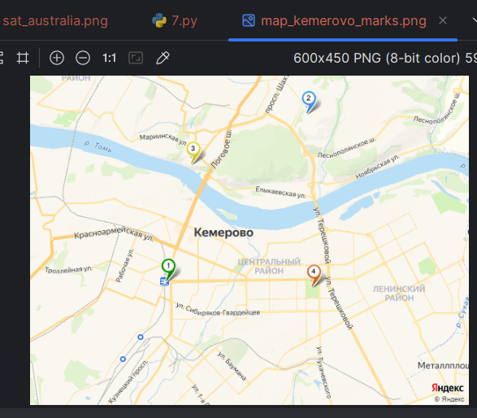

**8 задание**

import requests  
  
response = requests.get("https://static-maps.yandex.ru/1.x/?ll=88.365701%2C54.605293&spn=2.5,2.9&l=map&" +  
 "pl=86.107338%2C55.338070,86.213270%2C55.175653,86.229957%2C55.153833,86.278425%2C54.849400," +  
 "86.208463%2C54.801052,86.229035%2C54.741636,86.173111%2C54.665867,86.323659%2C54.582647," +  
 "86.350774%2C54.539580,86.365844%2C54.494871,86.519405%2C54.233129,86.805692%2C54.056053," +  
 "86.902603%2C53.818733,87.140770%2C53.758963,87.186473%2C53.486263,87.128217%2C53.320871," +  
 "87.148293%2C53.310017,87.129996%2C53.225853,87.524175%2C53.099552,87.673337%2C53.036962,87.736649%2C52.980124," +  
 "87.769463%2C52.898835,87.862995%2C52.890680,87.987732%2C52.929364")  
map_file = "map_road.png"  
with open(map_file, "wb") as file:  
 file.write(response.content)

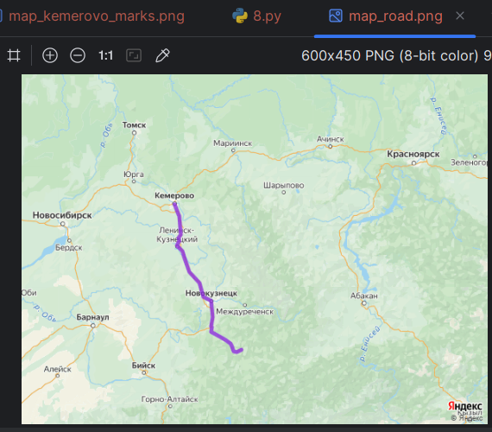

**11 задание**

from urllib.request import urlopen  
from bs4 import BeautifulSoup  
  
r = 'http://olympus.realpython.org/profiles'  
page = urlopen(r)  
html_text = page.read().decode('utf-8')  
soup = BeautifulSoup(html_text, "html.parser")  
  
links = set()  
  
for link in soup.find_all('a'):  
 l = link.get('href')  
 if l != None:  
 links.add(l)  
  
for link in links:  
 print(f'{r[:-9]}{link}')

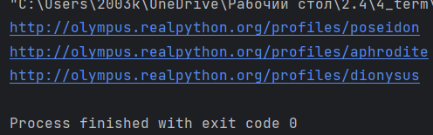

**12 задание**

from bs4 import BeautifulSoup  
import requests  
  
url = "https://quotes.toscrape.com/"  
page = "page/"  
count_page = 10  
authors = {}  
  
for i in range(count_page):  
 response = requests.get(url + page + str(i + 1))  
 soup = BeautifulSoup(response.text, "html.parser")  
 for author in soup.find_all("small", class_="author"):  
 if author.text not in authors:  
 authors[author.text] = 1  
 else:  
 authors[author.text] += 1  
  
sorted_tuples = sorted(authors.items(), key=lambda item: -item[1])  
sorted_authors = {k: v for k, v in sorted_tuples}  
  
for k, v in sorted_authors.items():  
 print(k, ": ", v)

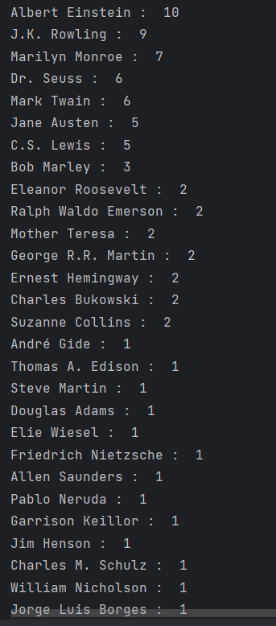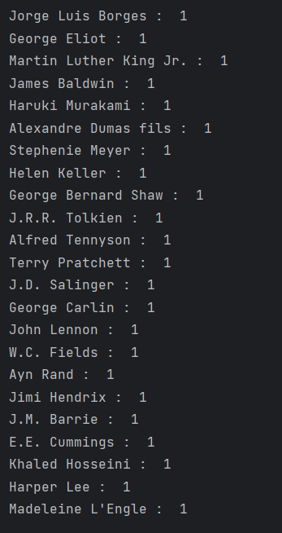

**13 задание**

from bs4 import BeautifulSoup  
import requests  
from random import choice  
  
url = "https://quotes.toscrape.com/"  
page = "page/"  
count_page = 10  
quotes = []  
  
for i in range(count_page):  
 response = requests.get(url + page + str(i + 1))  
 soup = BeautifulSoup(response.text, "html.parser")  
 for quote in soup.find_all("span", class_="text"):  
 quotes.append(quote.text)  
  
for i in range(5):  
 print(i + 1, ")", sep="")  
 print(choice(quotes))

